**Setting Up Application Environment**

|  |  |
| --- | --- |
| Date | 3 NOV 2022 |
| Team ID | PNT2022TMID46979 |
| Project Name | Smart fashion Recommender Application |
| Team Members: | Muthuvel,pothiraj,manoj,dharun babu |

**Docker Installation**

**Step 1:**

Go the official Docker website: [***https://docs.docker.com/desktop/install/windows-***](https://docs.docker.com/desktop/install/windows-install/)

[***install/***](https://docs.docker.com/desktop/install/windows-install/) 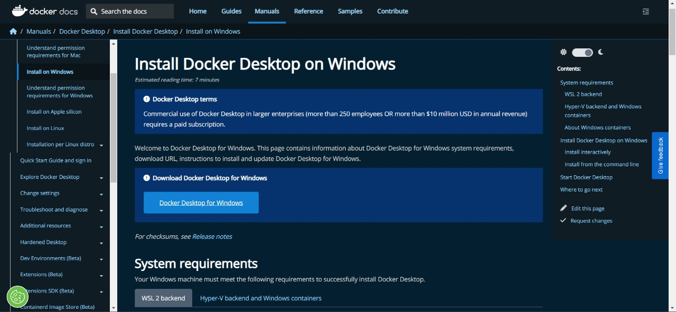

**Step 2:**

Click that button (Docker Desktop for Windows) and download will start and it takes few minutes to complete.

**Step 3:**

Go to downloads in browser (or) type **ctrl + J**, it will navigate to download page and double-click the particular docker file.

**Step 4:**

Now Installation is complete. This icon was added in your desktop. Double-click the icon to start the docker app, you can register and login that app to access those credentials.

**Step 5:**

Docker will start correctly, the left bottom side was shown in green color, docker will show the status of docker app working successfully. 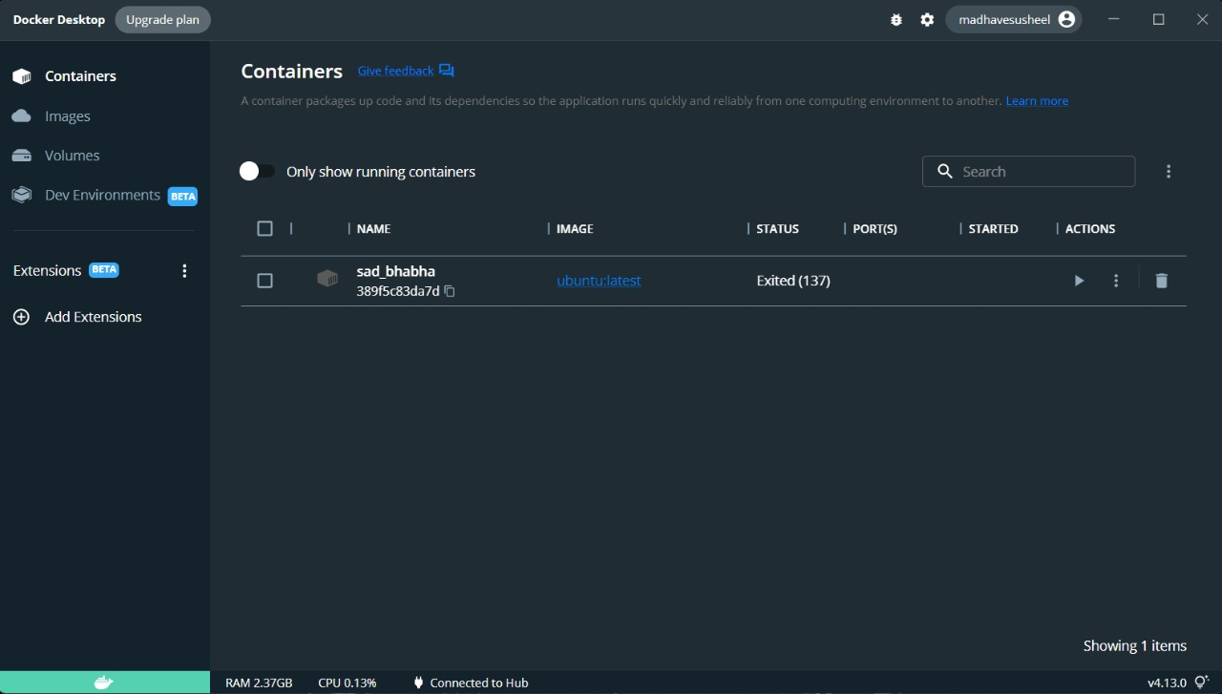

**Step 6:**

Finally, the docker is installed successfully.